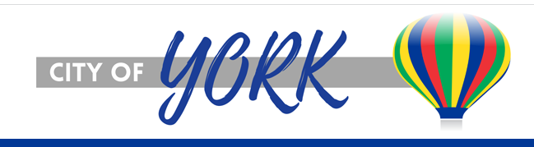

Daytime Event Specialist
The City of York is seeking to hire a part-time Event Specialist at the Holthus Convention Center. The Event Specialist is responsible for assisting with preparation and overseeing of convention center events including: greeting guests, answering calls, assisting with tours, assisting with scheduling, preparation and overseeing of events and pre and post event set up and clean up.
Essential duties:
Assist with scheduling of events and communicating with organization representatives
Assist with preparation and overseeing of events
Work closely with clients to ensure high level of customer service
Effectively communicate with clients in friendly and positive manner
Assist with facility marketing and promotional efforts

General Skills:

Excellent organization and planning skills

Attention to detail

Ability to prioritize multiple projects and work under pressure

Working knowledge of Canva Design Program

Normal working hours M-F 10 am – 2 pm – with flexibility to work evenings and weekends, if necessary

Ability to frequently exert up to 25 lbs. and up to 50 lbs. on occasion

Education & Experience

High school diploma or equivalent

3 to 5 years of work experience

Applicant must be 18 years of age and authorized to work in the United States.

Salary: $15.50 per hour
Apply online at www.cityofyork.net or e-mail application to dpfeifer@cityofyork.ne.gov. Applications will be accepted until position is filled.

City of York is an Equal Opportunity Employer

